Exit Assignment – ReadMe

This folder contains all need file to run exit test that is let us say Product_Review.

**Instructions to run :**

The frontend part path needs to be run on cmd the then further the following commands should run :

1. npm install- to install all required node modules.
2. ng serve – to run on 4200 port

Coming to backend folder .:

1. This needs to be imported in eclipse as a existing maven project.
2. In backend folder -> src -> main -> java ->com -> exittest ->backend ->resources -> application.properties

Set database name and localhost sql path, username and password in lines 2 ,3 and 4 respectively.

1. Set port as 9090 and run the project as a spring boot project.

For Admin User.

To create an admin, run both frontend and backend together and the go to mySQL and there run the following queries :

1. Register the credentials of admin as normal user at the starting only.
2. use database_name;

update user_role set role_role_id='99' where user_role_id='1'

1. use exittest1;

insert into roles(role_id,ole_name) values(‘99’, ‘ADMIN’);

**Some Screenshots of running models are : (There are other module the search, add review also included)**

1. Login page

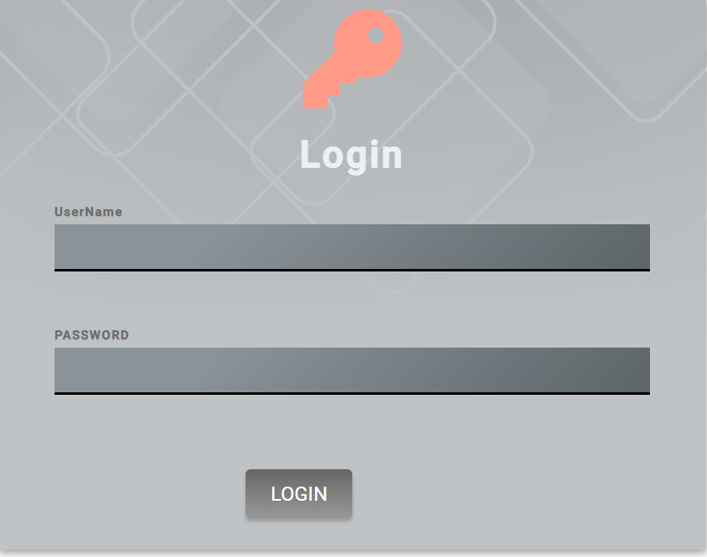

1. Register page

1. Admin page

1. General User page

1. Add products

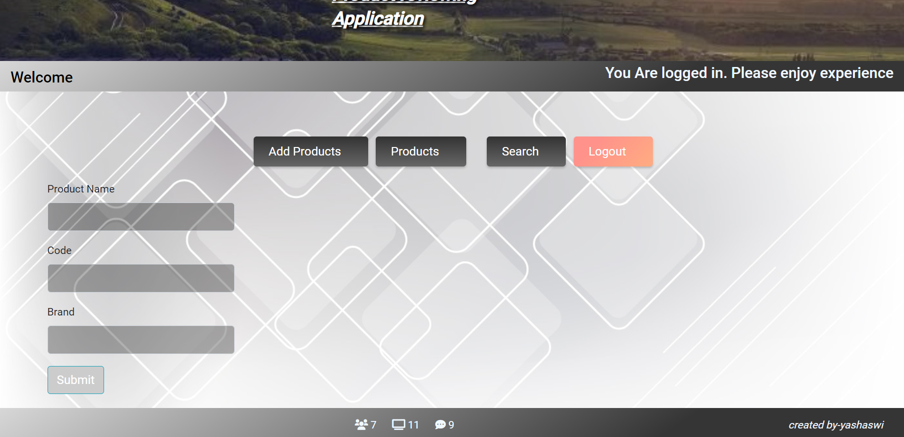

1. View Product

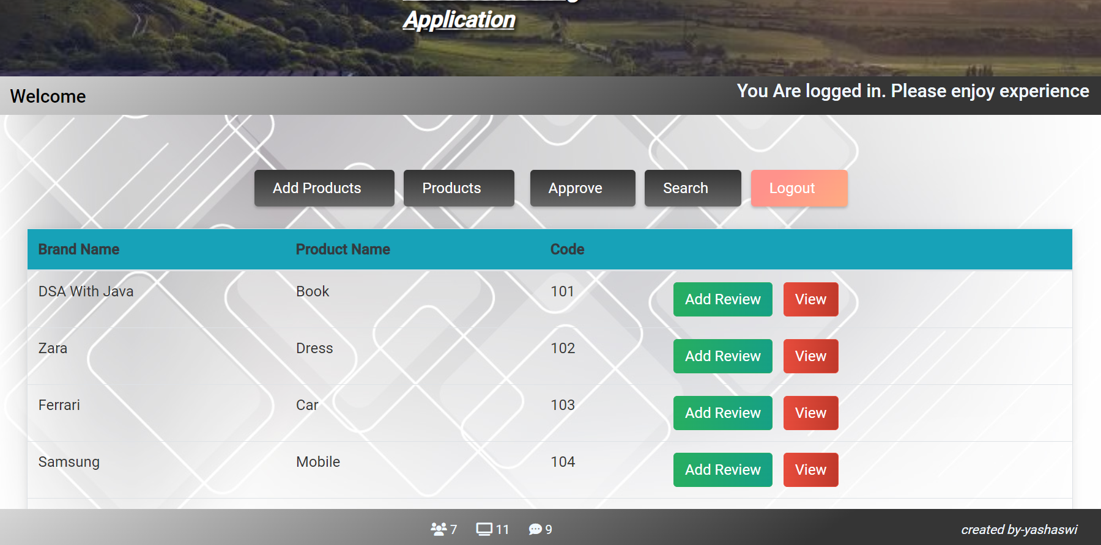

7.View reviews

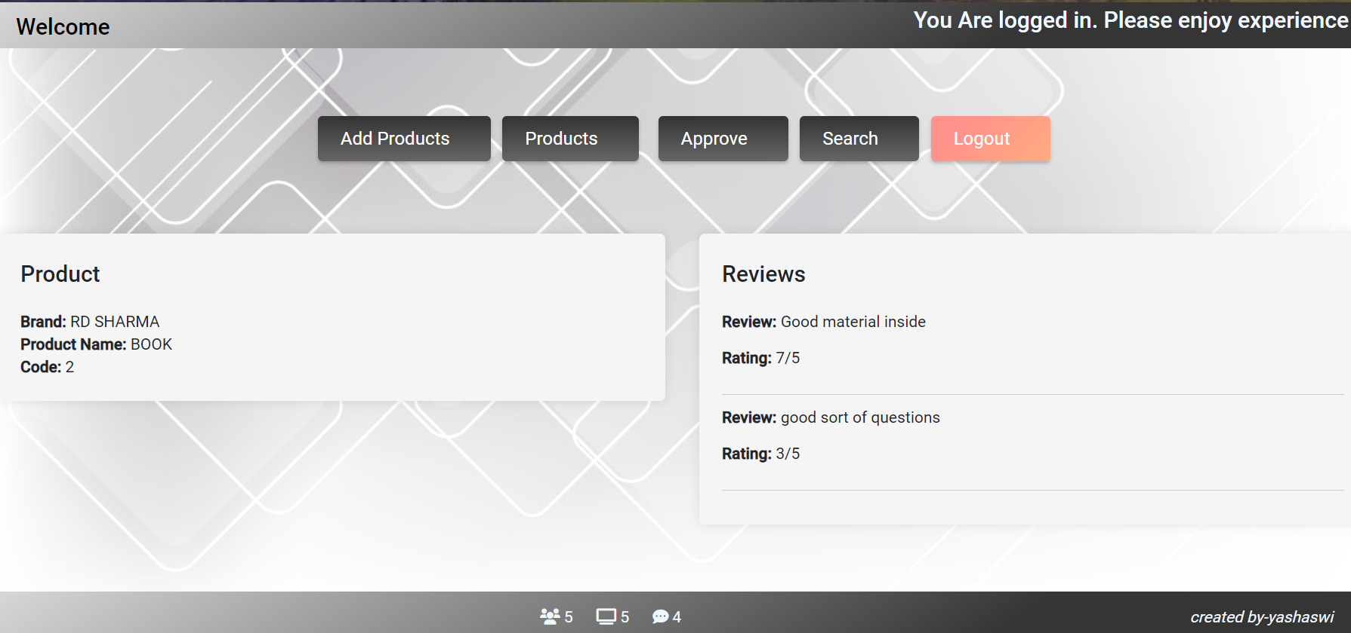

8.Approve/Disapprove

